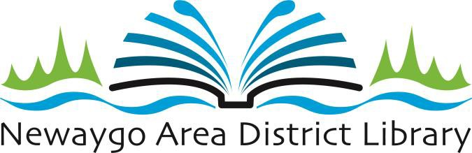

# AGENDA

**Regular Meeting of the Board of Trustees April 15, 2025**

**5:30 PM**

* **CALL TO ORDER**
  + Roll Call.
  + Approval of Agenda. (Motion)

# MINUTES

* + Approval of Minutes of Regular Board Meeting of March 18, 2025. (Motion)

# PUBLIC COMMENTS

Members of the public may address the Board on any agenda item. Comments are limited to a maximum of three (3) minutes per citizen. Please state your name and address for the records.

# TREASURER’S REPORT AND BILLS AND CASH DISBURSEMENTS (Motion)

* + - CD Renewal – April 15

# DIRECTOR’S REPORT

* **UNFINISHED BUSINESS**
  + Library Annual Financial Audit Update
  + Earned Sick Time Act implementation
  + Personnel

* **NEW BUSINESS**

# PUBLIC COMMENTS

Comments are limited to a maximum of three (3) minutes per citizen. Please state your name and address for the records.

# BOARD MEMBER COMMENTS

* **ADJOURNMENT** (Motion)